CHAPTER 3

3. MATERIALS AND METHODS

3.1. Introduction

The study of fish diversity and distribution in the river Wiwi is an important aspect of understanding the ecological dynamics of this freshwater ecosystem. River Wiwi is one of the complex and diverse habitats that support a wide range of fish species, each with unique adaptations and roles within the food web. This study seeks to understand the number of different species present in river Wiwi and how species are spread throughout the river which is located in Kumasi the capital of Ashanti region

3.2 Research approach

An experimental study that examines the physical, chemical and biological characteristics using a combination of quantitative and qualitative methods.

3.3 Study area

The study was carried out in river Wiwi which is situated in Kumasi, the Ashanti region’s capital. It is part of Ghana’s semi-deciduous zone. River Wiwi which is a small river passes through few communities in Kumasi.

River Wiwi arises from Nsunyameye near Aboabo Nkwanta is the north eastern part of Kumasi in the Ashanti region of Ghana and flows in the north eastern direction. The length of the river is about 8km from the source up to the point where the river meets another stream called the Sisai river *(Sammy et al 2013).*

The river source lies at Lat.6º north of the equator and long 1º32’ east of the Meridian.At Lat. 6º 49’ North of the equator and long 1º 35’ East of the Meridian. It is about 35.5m above sea level (Sammy et al 2013). The river Wiwi provides a variety of life forms including fishes and other aquatic organisms. It is a significant source of water for several communities in Kumasi especially for those around KNUST and surroundings.

The study area was divided into a section of three(3), starting from upstream , through midstream to downstream of the river’s flow.The upstream was selected at Asunyameye near Aboabo Nkwanta and the midstream and the downstram were selected within the university based on the activities that goes on at the river.The river in the KNUST botanical garden was chosen as midstream due to less anthropogenic activities and the downstream was chosen under the bridge because there is more anthropogenic activities.

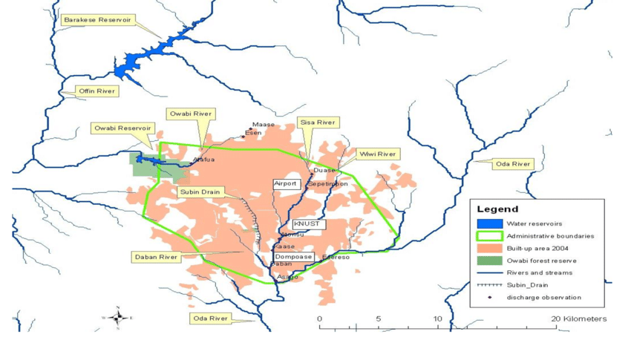

Figure 3.1: River Wiwi and other streams that drain the Kumasi Metropolis

3.4 Enironmental survey

3.4.1 Upstream

The upstream of the river Wiwi was taken at Abbirem Nkwanta in Kumasi . The colour of the river varies from time to time, there is low or no fishes present when it rains due to its dirty colour and turbulences. During the month of January to March, the river was brown in colour . But during April to May the colour of the river was very clear ,as a result high number of aquatic organisms were recorded which includes crabs, fishes and other invertebrates like tadpoles too were present. There is a lot of rocks and vegetation present at the midstream but there is also more of anthropogenic activities that goes on around the river .The temperature was recorded in the morning was 31.4º , afternoon was 31.2º and evening was 32.5º. The length (L)was recorded as 55.60m , depth(d) 2.70m , width(W) 0.50m and distance (D) 20.813. The velocity(V) was calculated as 0.431ms-1 , area(A) 351.948m and discharge (Q) 151.549m2/s

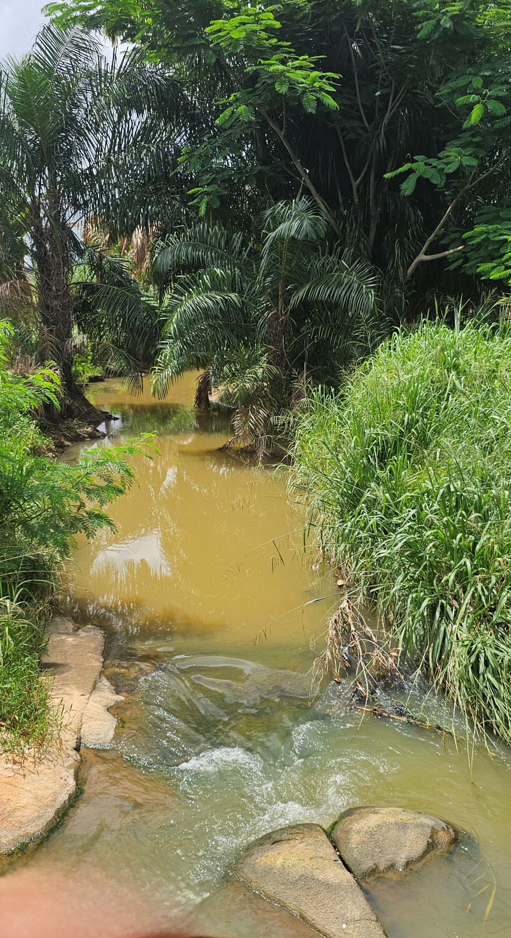

Figure 3.2.1 Upstream of River Wiwi

**3.4.2 Midstream**

The midstream of the river Wiwi was taken at Wiwiso located at Kumasi muncipality. The clarity of the river varies depending on the season. During the month of April the colour of the river was observed to be very clear as a result a high number of fishes and other aquatic organisms were seen. But during the month of May the clarity of the water reduced , it was observed to brown in colour. As a result low or no species of fish were recorde during this season. Apart of fishes, other organisms such as tadpole , chirligig bettle , crab, mosquito larva and snakes were seen. There is no or no rocks present, as a result the turbulence was low and continuous flow of the river. Temperature variation from morning , afternoon and evening were recorded as 28.1 º, 27.9º and 31.2º. The depth(d) was recorded as 0.627m, width(W) 5.380m, distance(D) 46.1m and length(L) is 43.590m. The area (A)was recorded as 234.514m2 . The velocity was calculated as 0.363ms-1 and the discharge(Q) 85.129m2s-1

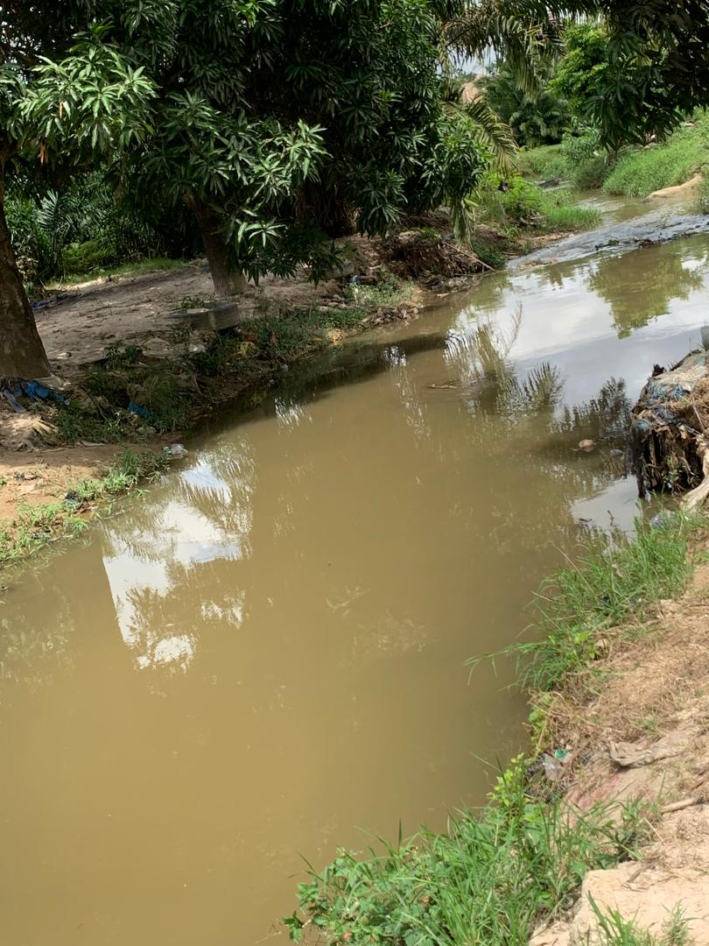

Fig 3.2.2: Midstream of river Wiwi

**3.4.3 Downstream**

The downstream section of the river Wiwi was taken at KNUST botanical gardens which faces pollution challenges from urban activities and agricultural practices, impacting water quality and ecosystem health. The clarity of the river is dark brown through out the seaseon as a result the fishes present are pollution tolerant. There is a lot of anthropogenic activities hence the diversity of the fishes reduced with time.There is a lot of vegetation present but no or low number of rocks were recorded. The temperature recorded was as follows; morning 29.0 º, afternoon 33.7º and evening 31.1º. The width(W) was recorded as 4.95m , length(L) 5.47m , depth(d) 3.91m and distance(D) 1.46m . The area(A) was calculated as 27.08m2 , velocity(V) as 0.04ms-1 and discharge (Q) as 1.06m2s-1 .

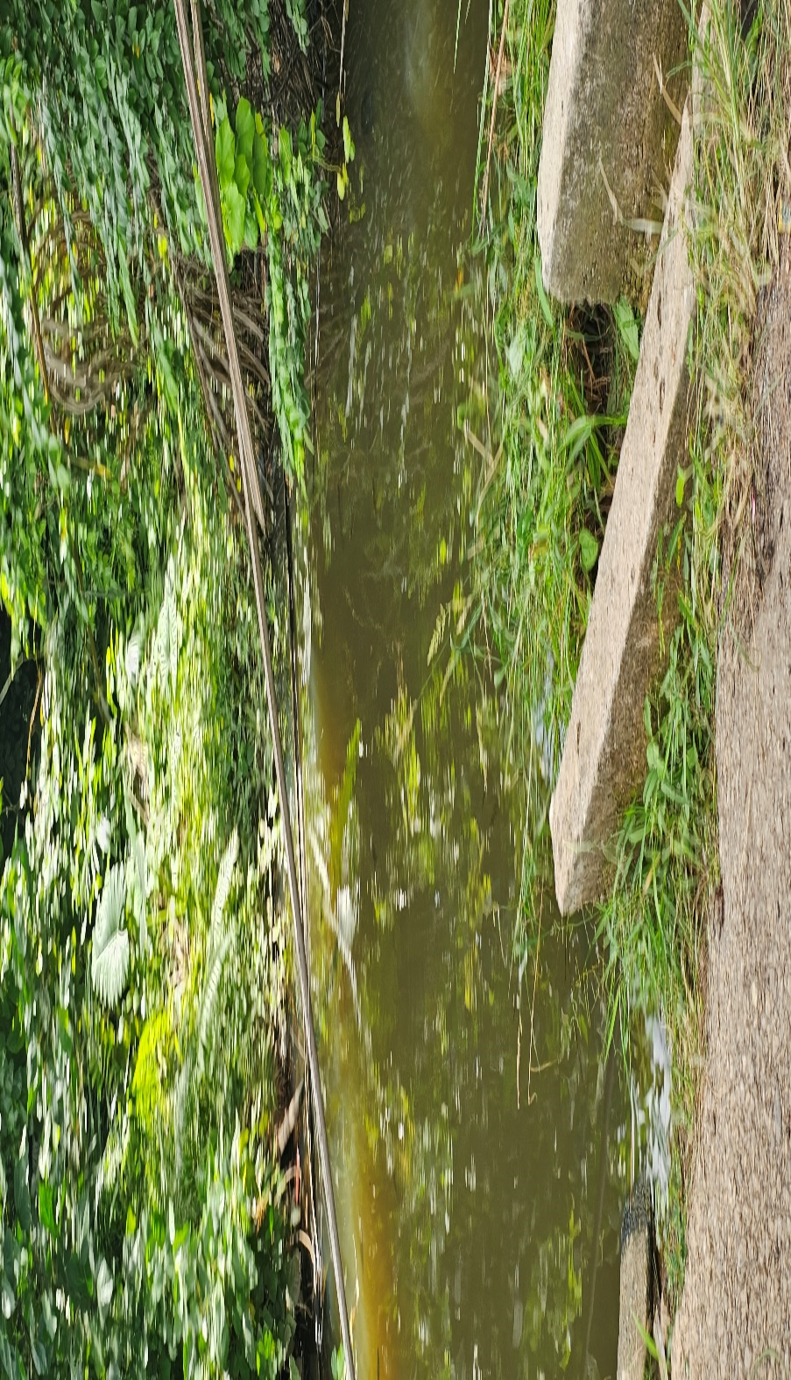

Fig 3.2.3: Downstream of River Wiwi

3.5 Materials and methods

3.5.1 Materials

2. Fishing net

3. Gloves

4. Basins

5. Rope

6. Tape measure

7. Thread

8. Mercury thermometer

3.5.2 Sampling procedure

1. A reference point along the river with a very optimum flow was selected
2. A reference area was chosen along the river which had different species of fishes and had a high number of the fishes present.
3. All the needed equipments for the sampling procedures such as fishing net, gloves, basin, rope, tape measure, thread, mercury thermometer were used .
4. The selected sampling area was carefully chosen , with no or little disturbance. The particular areas to pick the samples were selected. Gloves were worn and samples were collected into the sampling container .
5. The fishing net was used to catch any type of fishes needed.
6. The important information about the sampling area were recorded including the date, time , temperature, current and other informations were recorded.
7. The sampling procedure was repeated several times at each stream (upstream, midstream and downstream) of the river
8. Basins were used to store the samples collected. The basins were tightly closed and stored in a cool, dry place.

3.5.3 Physio-chemical parameters

3.5.3.1 Temperature

Mercury thermometer was used to measure the temperature in degree celcius(ºC). The mercurt thermometer was dipped directly in the water to measure the surface temperature. Three measurements were taken at each stream and an average was taken( T1+T2+T3)/3.

3.5.3.2 Current

The current was checked via direct observation of the river.

3.5.3.3 Water depth

3.5.3.3.1 Materials

Rope, tape measure, permanent maker pen and stone.

3.5.3.3.2 Procedure

A reference point was selected at the middle of the sampling area (upstream, midstream and downstream. The rope was attached to the stone. The middle of each stream was divided into three equal parts. For the first part, the stone that was tied to the rope was dipped into the river until it hit the bottom.

The stone attached to the rope was removed and the permanent marker was used to mark the wet part of the rope as a reference point. The tape measure was used to take the measurement of the depth from the reference point on the rope to the end of the stone. The process was repeated at each part of the stream and an average of the depth at each site were determined. The same procedure was repeated at the various stream of the river.

3.5.3.4 Velocity

3.5.3.4.1 Materials

Tape measure, stop clock and floating object

3.5.3.4.2 Procedure

Float method was used to measure the velocity of the river at each sampling site. A known distance was determined along the direction of the flowing river . A distance was measured using sticks, stick X and stick Y and recorded as XY. The floating object was dropped at stick X, the time was recorded from stick X and stopped at stick Y. The time taken for X to reach Y was recorded with a stop clock. The velocity was then calculated by the formula ;

Velocity = Distance between stick X and Y (m)/ Time (s).

This process was repeated three times for each stream and average was determined .

3.5.3.5 Water discharge

The velocity and area of the river was multiplied to determine the amount of water that passes through each sampling area. The discharge was determined by the formula;

Discharge(Q) = Velocity × Area

3.5.3.6 Water color

This was determined via visual observation that is colourless , muddy , brownish and cloudy

PREAMABLE: A device called Hackman multi-parameter probe was used to check for the conductivity, dissolved oxygen (DO) and PH .  Different procedure or method was used depending on the parameter that was been measured at that particular time.

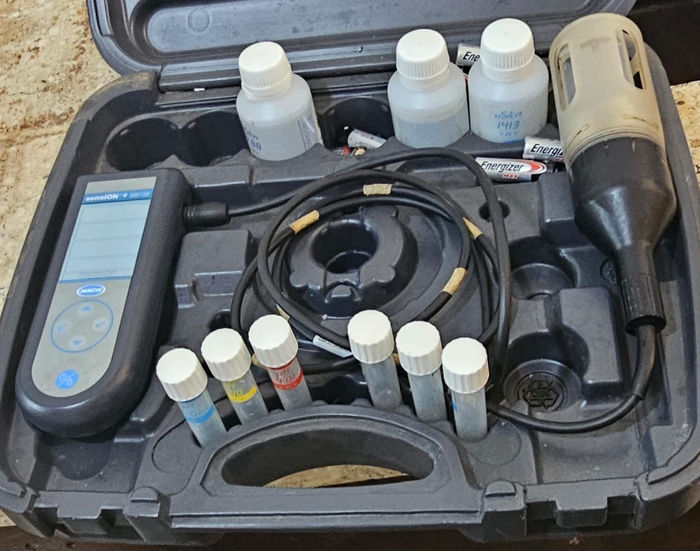

Fig 3.2.4: Hackman multi-parameter probe

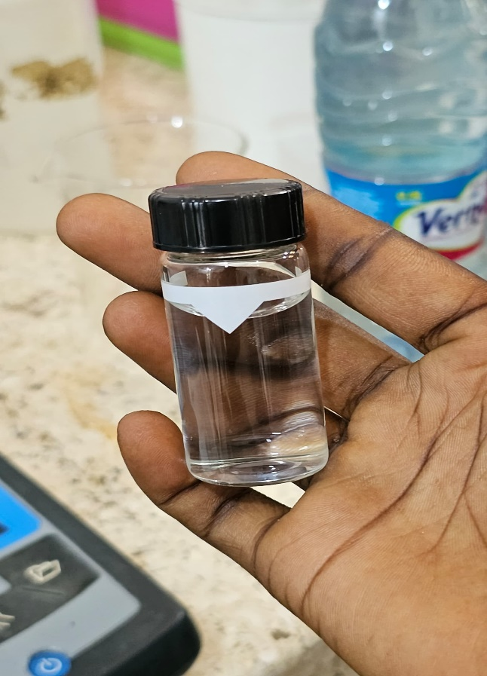

Fig 3.2.5: The turbidimeter reading flask

3.5.3.7Turbidity

Portable turbidimeter was used.

Turbidimeter reading flask or sample cell with distilled water inside was used . The turbidity reading flask was cleaned with an unused tissue . This is because light of a particular wavelength was used. The distilled water in the cell was used to calibrate it to get 0.45ntu. After the device was calibrated, 0.3ml samples of the river from all the various stream (upstream, midstream and downstream) was used. The Hackman multi-parameter probe was dipped into the 0.3ml of the samples in the sample cell . After the values of the various streams were recorded, the calibrated value which is 0.45ntu was subtracted from it to get the actual value.

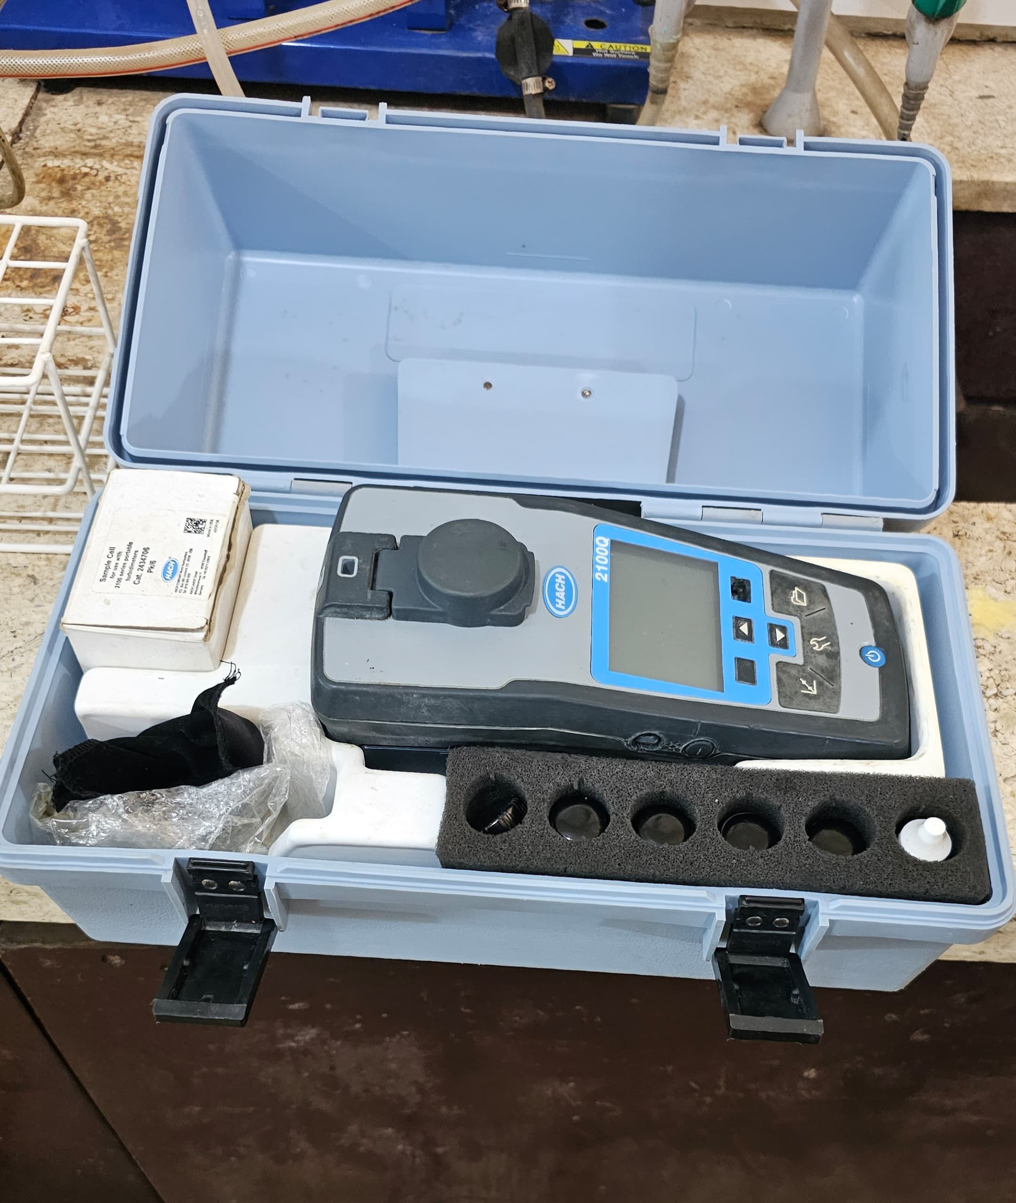

Fig 3.2.6: Portable turbidimeter

3.5.3.8 Dissolved Oxygen

The Hackman multi-parameter probe was dipped inside the 0.3ml sample of all the various stream (upstream , midstream and downstream) of the river which was contained in the sample cell. It was dipped in it until the device started reading , this was done by preventing any air interference thus, all windows and fan was shut down for an accurate results. The values were recorded in percentage.

3.5.3.9Conductivity

The Hackman multi-parameter probe was dipped inside the 0.3ml sample of all the various stream (upstream , midstream and downstream) of the river which was contained in the sample cell. It was dipped in it until the device started reading , this was done by preventing any air interference thus, all windows and fan was shut down for an accurate results. The values were recorded in percentage.

3.5.3.10 Hydrogen ion concentration (Ph)

The Hackman multi-parameter probe was dipped inside the 0.3ml sample of all the various stream (upstream , midstream and downstream) of the river which was contained in the sample cell. It was dipped in it until the device started reading , this was done by preventing any air interference thus, all windows and fan was shut down for an accurate results. The values were recorded in percentage.

3.5.3.11 Total nitrate and phosphate

The amount was total nitrate and phosphate were measured, which serves as the nutrients in the river. High amount can lead to hypertrophication whilst low amount can lead to eutrophication .

PREAMBLE

Spectrophotometer was used to check for the amount of nutrients present in the river, specifically the amount of nitrate and phosphate. This device works on the principle of wavelength , hence specific wavelength was used depending on the nutrient of interest. A cuvette which contained distilled water was used to calibrate the spectrophotometer, and the calibration value was read as 0.00

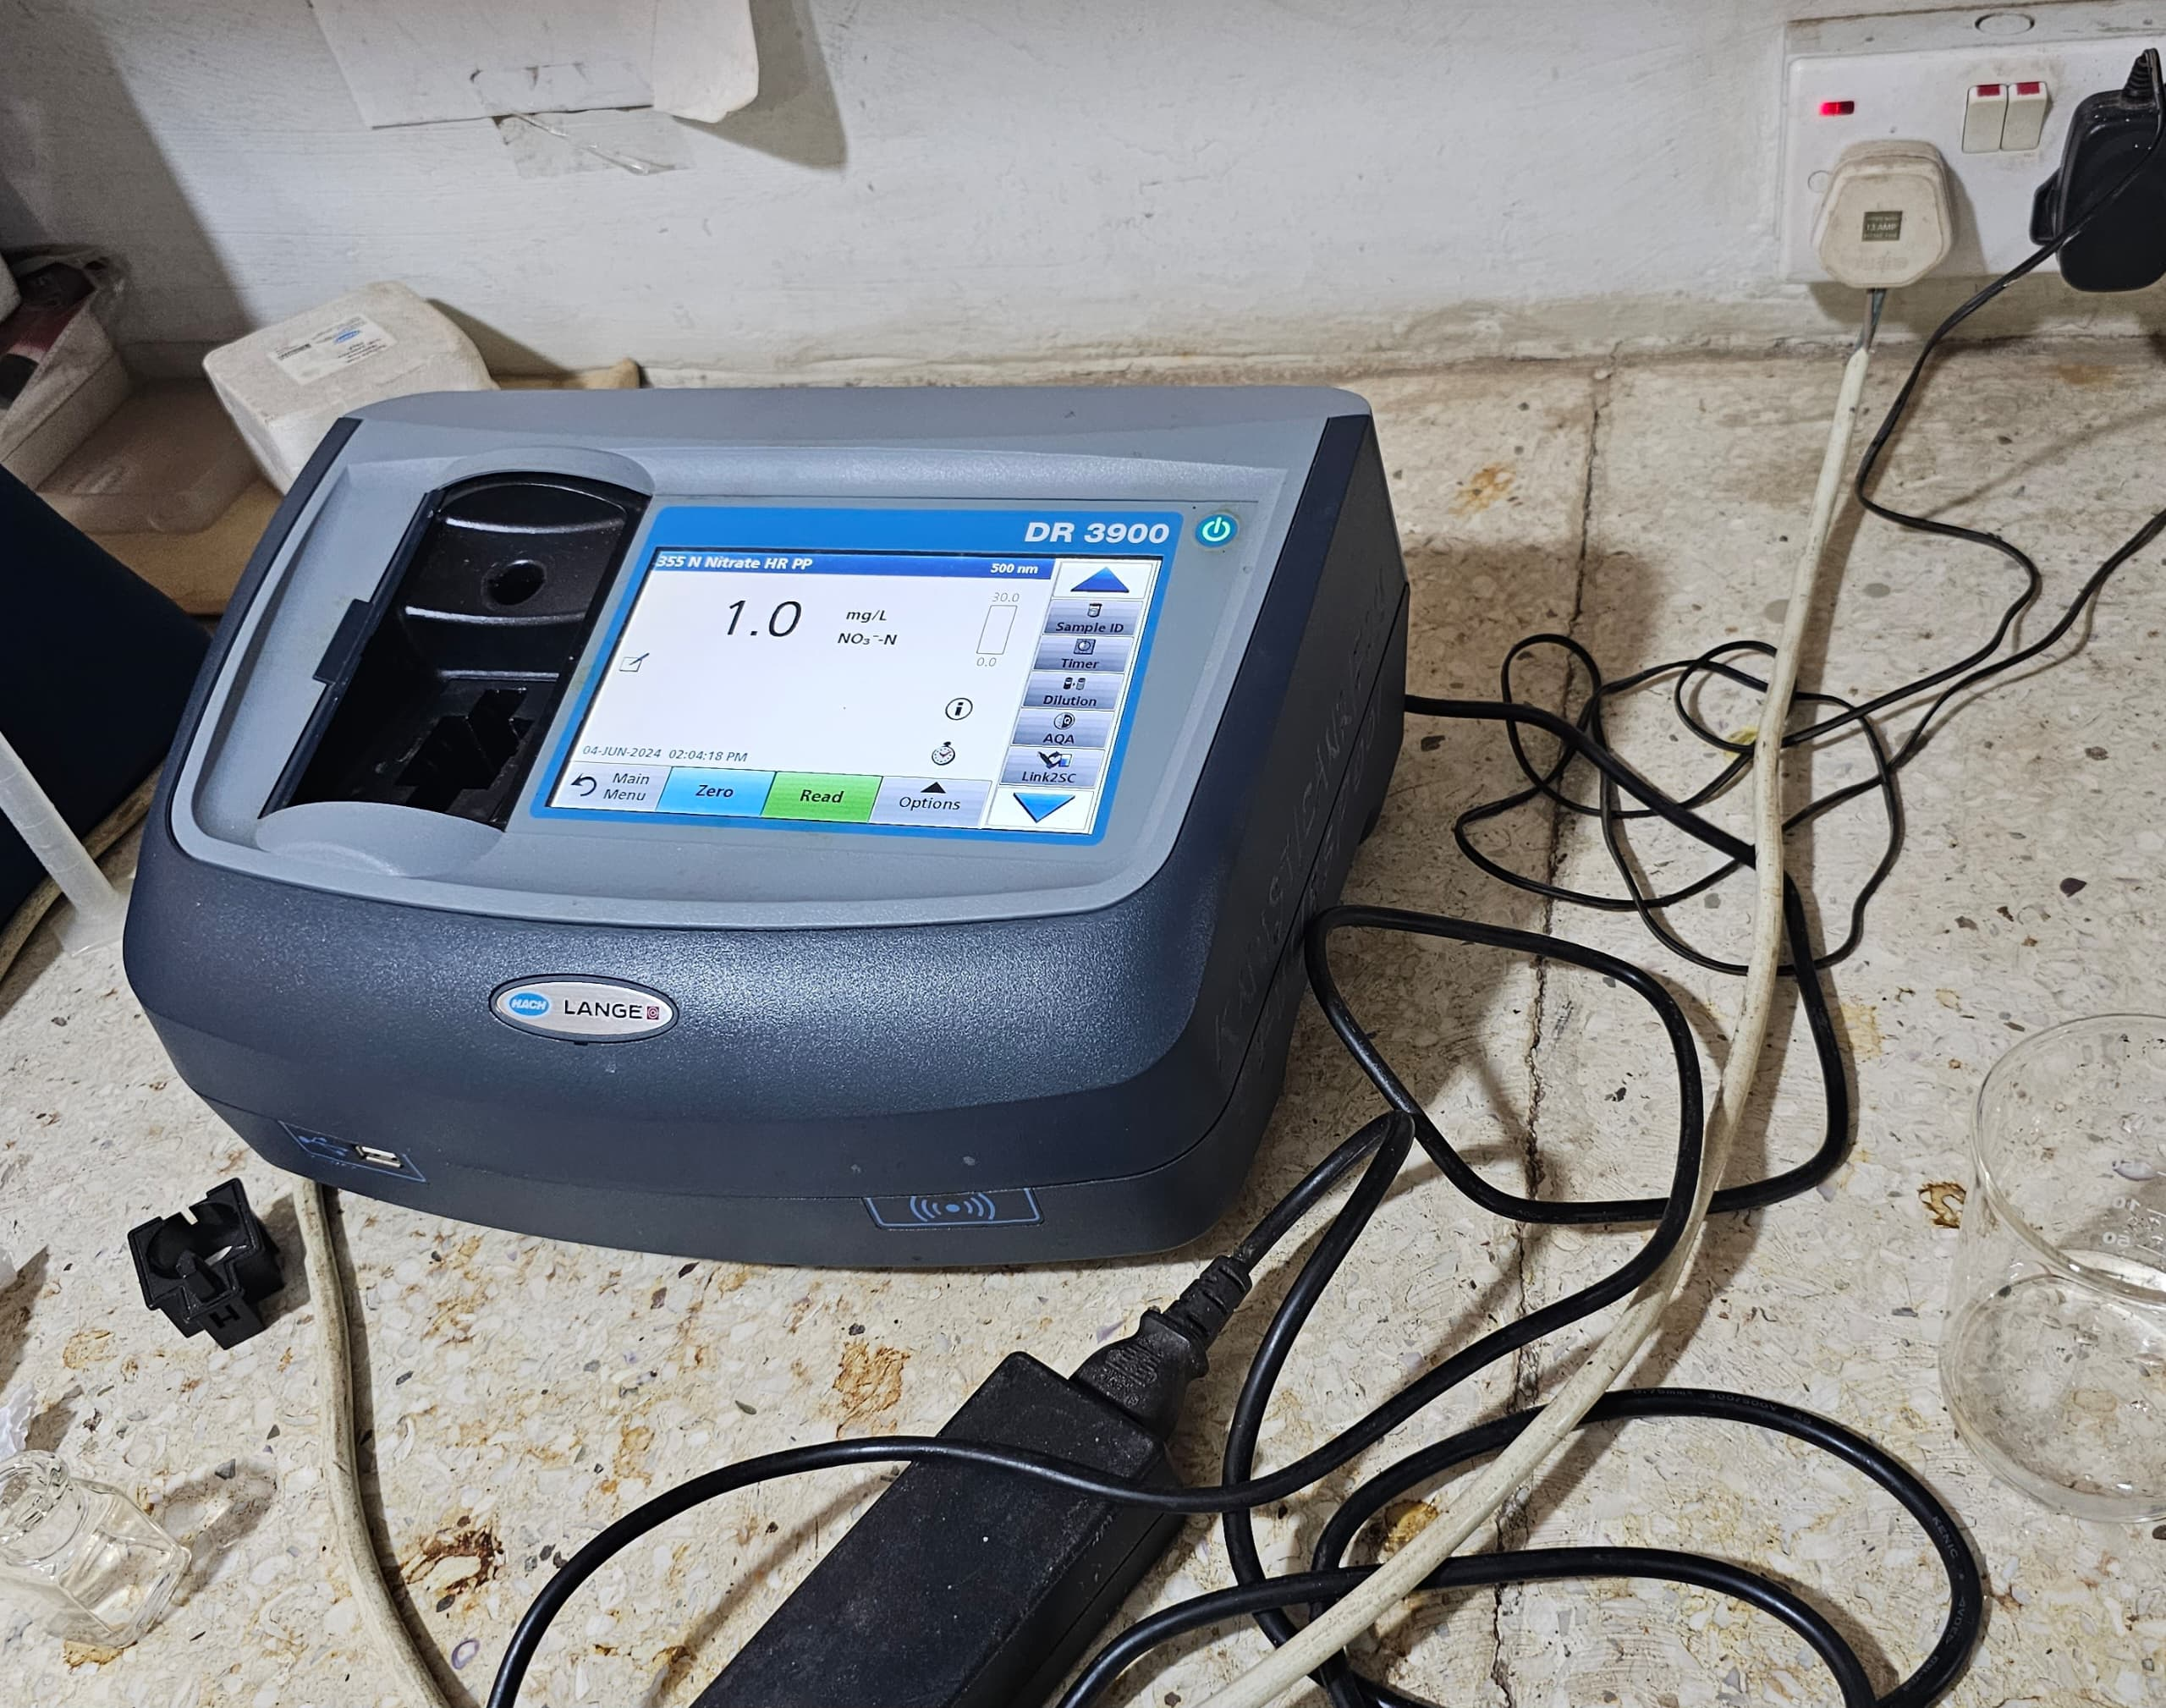

Fig 3.2.7: A spectrophotometer.

3.5.3.11.1 Total mitrate

2.0ml of the river sample from all the various streams(upstream, midstream and downstream) was placed in a measuring flask. After this, 8.0ml of distilled water was added to the 2.0ml of the river sample in the measuring flask. A nitrate pillow, a chemical used to detect for the presence of nitrate was added to the solution in the measuring flask. The sample was allowed to settled and waited for 5 minutes. A wavelength of 500nm was set on the spectrophotometer and the readings

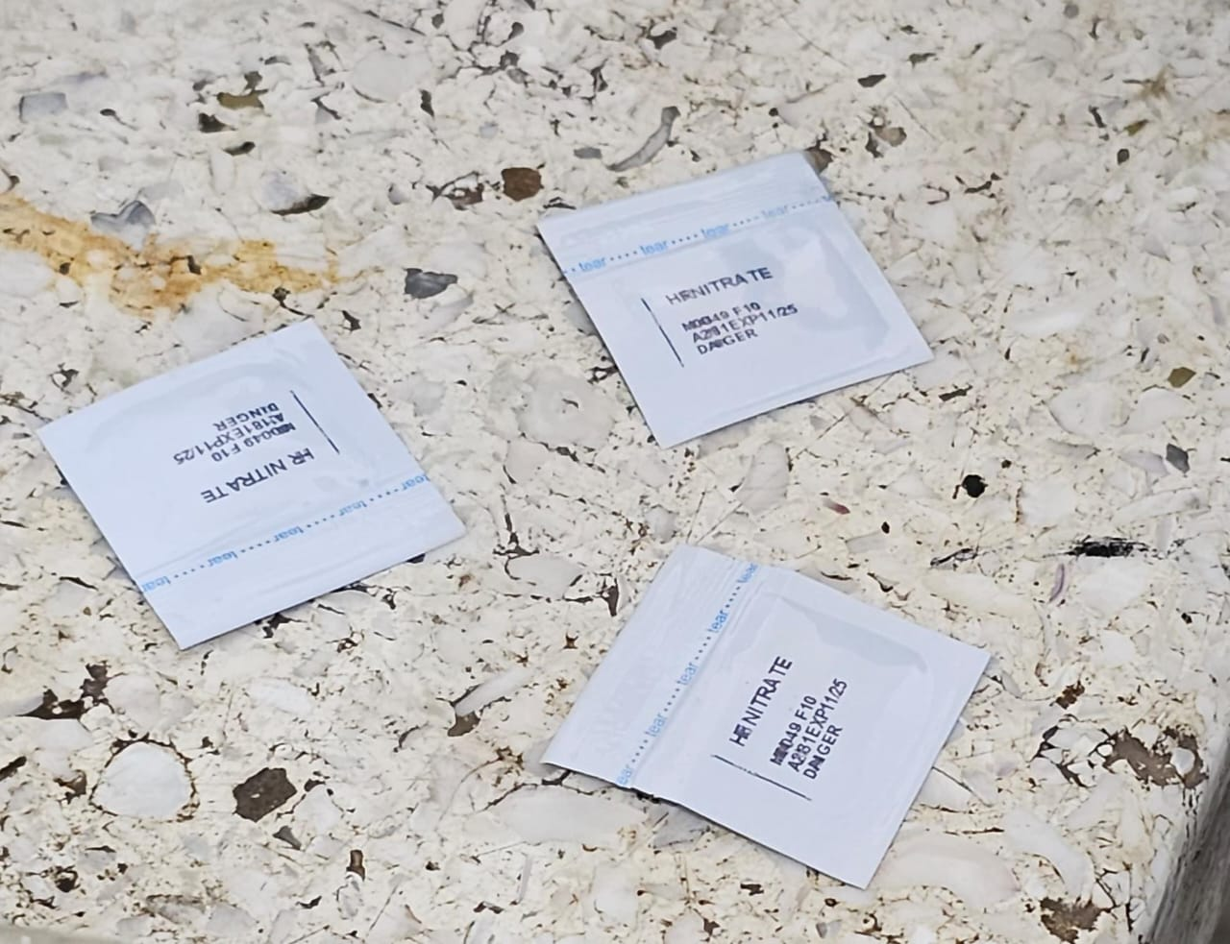Fig 3.2.8: Nitrate pillows

3.5.3.11.2 Total phosphate

2.0ml of the river sample from all the various streams(upstream, midstream and downstream) was placed in a measuring flask. After this, 8.0ml of distilled water was added to the 2.0ml of the river sample in the measuring flask. A nitrate pillow, a chemical used to detect for the presence of nitrate was added to the solution in the measuring flask. The sample was allowed to settled and waited for 3 minutes. A wavelength of 880nm was set on the spectrophotometer and the readings were recorded.

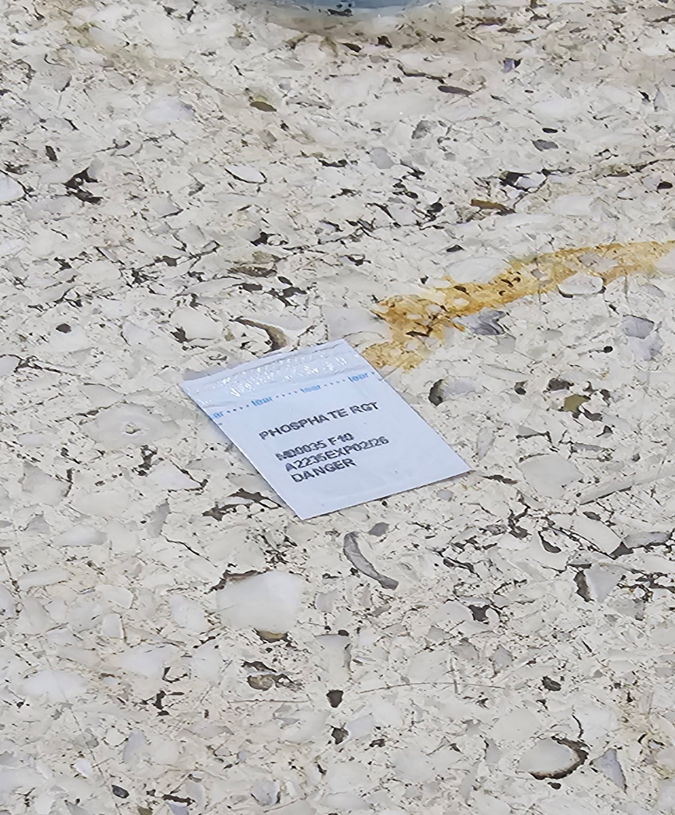

Fig 3.2.9: Phosphate pillow

3.5.3.11.3 Method of collection.

A fishing net was used to catch the various fishes species at Abirem, Wiwiso and KNUST botanical gardens. Different species of fishes are adapted to various microhabitat in the river. Certain fishes have the ability to camouflage with the environment which made it difficult to identify them. Others too have the ability to hide under the soil and rocks as a form of protection against potential predators. The shape of the caudal fin gave some species a higher advantage over others since forked shaped fishes are very fast. With all this adaptations, quite a significant amount of some fish species were collected by throwing the net over the river. Large variety of fish species were not found due to overfishing and construction of infrastructures such as dams, bridges factors and so on. Certain species too were known to be extinct over the years. Because are focus is on the distribution and diversity of fishes, the fishes collected were counted, measured and recorded. After this, they were throwback into the river body. This was done to continue and conserve biodiversity. No chemicals were used to extract the fishes from the river.

3.6 Data analysis

The data analysis collected was performed using Microsoft excel spreadsheet. The results were presented using descriptive statistics which includes graph and pie chart.